Examination Result and Grace Marks
1. Problem Statement
Write a Python program to calculate a student's examination result by applying grace marks. The program accepts the number of subjects and marks in each subject. It applies 5 grace marks to students who score below 35 but can reach 35 with grace marks. Finally, it calculates the percentage and displays the result as Distinction, First Class, Second Class, Pass or Fail.
2. Assumptions
- The number of subjects must be greater than zero.
- Each subject mark must be between 0 and 100.
- The minimum pass mark is 35.
- Maximum grace marks are 5.
- Grace marks are added only when the student can reach 35.
- Percentage is calculated using final marks.
3. Algorithm
- Start the program.
- Read the number of subjects.
- Initialize an empty marks list.
- Set grace marks to 5 and maximum marks to 100.
- Read marks for each subject.
- Check whether marks are valid (0–100).
- Apply grace marks if marks are below 35 and can reach 35.
- Display final marks.
- Check whether all subjects have at least 35 marks.
- If passed, calculate percentage.
- Display the result according to percentage:
  - 75% or above – Distinction.
  - 60% or above – First Class.
  - 50% or above – Second Class.
  - Below 50% – Pass.
• Otherwise, display Fail.
1. Stop the program.
2. pesudo code

Enter number of subjects: 5
Enter subject marks: 32
Enter subject marks: 60
Enter subject marks: 70
Enter subject marks: 80
Enter subject marks: 90

Final Marks: [37, 60, 70, 80, 90]
Percentage: 67.4
Enter number of subjects: 5
Enter subject marks: 32
Enter subject marks: 60
Enter subject marks: 70
Enter subject marks: 80
Enter subject marks: 90

Final Marks: [37, 60, 70, 80, 90]
Percentage: 67.4
Result: First Class

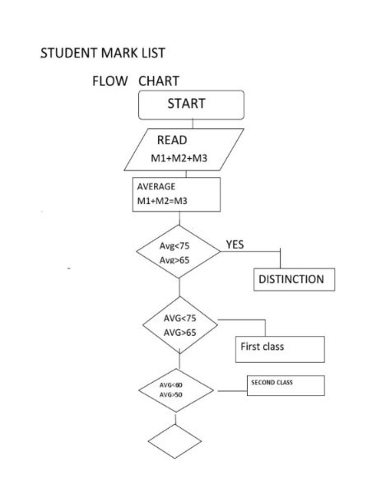
The conclusion
The program successfully calculates the examination result by applying grace marks wherever required. It checks pass eligibility, calculates the percentage and classifies the student's result based on the percentage obtained.

